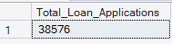
SELECT COUNT(id) AS Total_Loan_Applications FROM bank_loan_data
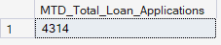
select COUNT(id) AS MTD_Total_Loan_Applications from bank_loan_data
where MONTH(issue_date) = 12 and YEAR(issue_date)=2021

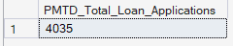
select COUNT(id) AS PMTD_Total_Loan_Applications from bank_loan_data
where MONTH(issue_date) = 11 and YEAR(issue_date)=2021

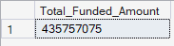

select SUM(loan_amount) as Total_Funded_Amount from bank_loan_data

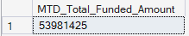

select SUM(loan_amount) as MTD_Total_Funded_Amount from bank_loan_data
where month(issue_date)= 12 and YEAR(issue_date)=2021

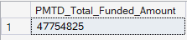
select SUM(loan_amount) as PMTD_Total_Funded_Amount from bank_loan_data
where month(issue_date)= 11 and YEAR(issue_date)=2021

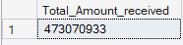

select sum(total_payment) as Total_Amount_received from bank_loan_data

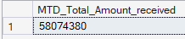

select sum(total_payment) as MTD_Total_Amount_received from bank_loan_data
where month(issue_date)=12 and YEAR(issue_date)=2021

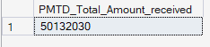

select sum(total_payment) as PMTD_Total_Amount_received from bank_loan_data
where month(issue_date)=11 and YEAR(issue_date)=2021

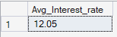
select round(avg(int_rate),4)*100 as Avg_Interest_rate from bank_loan_data

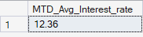
select round(avg(int_rate),4)*100 as MTD_Avg_Interest_rate from bank_loan_data
where month(issue_date)=12 and Year(issue_date)=2021

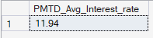
select round(avg(int_rate),4)*100 as PMTD_Avg_Interest_rate from bank_loan_data
where month(issue_date)=11 and Year(issue_date)=2021
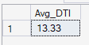
select round(avg(dti),4)*100 as Avg_DTI from bank_loan_data
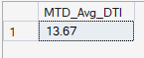
select round(avg(dti),4)*100 as MTD_Avg_DTI from bank_loan_data
where MONTH(issue_date)=12 and year(issue_date)=2021

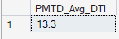
select round(avg(dti),4)*100 as PMTD_Avg_DTI from bank_loan_data
where MONTH(issue_date)=11 and year(issue_date)=2021
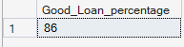
select
(COUNT(case when loan_status ='Fully Paid' or loan_status ='Current' then id End)*100)
/
count(id) as Good_Loan_percentage from bank_loan_data

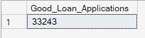
select count(id) as Good_Loan_Applications from bank_loan_data
where loan_status ='Full Paid' or loan_status ='Current'

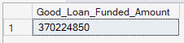
select SUM(loan_amount) as Good_Loan_Funded_Amount from bank_loan_data
where loan_status ='Full Paid' or loan_status ='Current'

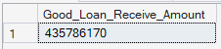

select SUM(total_payment) as Good_Loan_Receive_Amount from bank_loan_data
where loan_status ='Fully Paid' or loan_status ='Current'

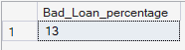

select
(COUNT(case when loan_status ='Charged Off' then id End)*100)
/
count(id) as Bad_Loan_percentage from bank_loan_data

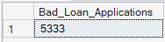
select count(id) as Bad_Loan_Applications from bank_loan_data
where loan_status ='Charged Off'

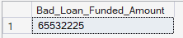
select SUM(loan_amount) as Bad_Loan_Funded_Amount from bank_loan_data
where loan_status ='Charged Off'

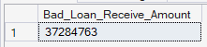
select SUM(total_payment) as Bad_Loan_Receive_Amount from bank_loan_data
where loan_status ='Charged Off'

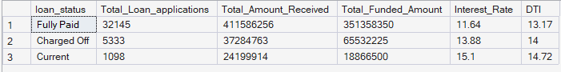

select
loan_status,
COUNT(id) AS Total_Loan_applications,
SUM(total_payment) AS Total_Amount_Received,
SUM(loan_amount) AS Total_Funded_Amount,
round( AVG (int_rate * 100),2) AS Interest_Rate,
round(AVG (dti * 100),2) AS DTI
FROM
bank_loan_data
GROUP BY
loan_status

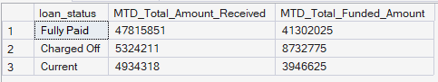

SELECT
loan_status,
SUM(total_payment) AS MTD_Total_Amount_Received,
SUM(loan_amount) AS MTD_Total_Funded_Amount
FROM bank_loan_data
WHERE MONTH(issue_date) = 12
GROUP BY loan_status

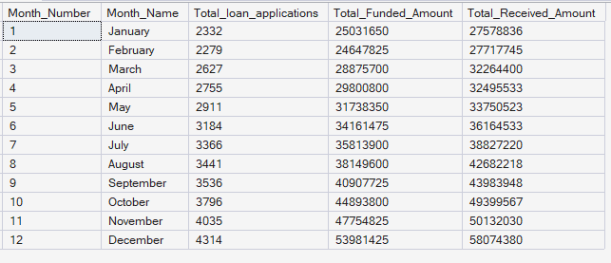

select
month(issue_date) as Month_Number,
DATENAME(month , issue_date) as Month_Name,
count(id) as Total_Loan_Applications,
sum(loan_amount) as Total_Funded_Amount,
Sum(total_payment) as Total_Received_Amount
from bank_loan_data
group by month(issue_date), DATENAME(month , issue_date)
order by Month(issue_date)

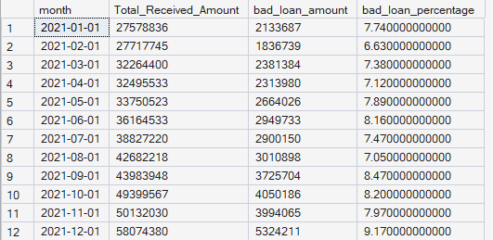
SELECT
DATEFROMPARTS(
YEAR(issue_date),
MONTH(issue_date),
1
) AS month,

SUM(total_payment) AS Total_Received_Amount,

SUM(
CASE
WHEN loan_status IN ('Charged Off', 'Default')
THEN total_payment
ELSE 0
END
) AS bad_loan_amount,

ROUND(
100.0 *
SUM(
CASE
WHEN loan_status IN ('Charged Off', 'Default')
THEN total_payment
ELSE 0
END
) / NULLIF(SUM(total_payment), 0),
2
) AS bad_loan_percentage

FROM bank_loan_data
GROUP BY
YEAR(issue_date),
MONTH(issue_date)
ORDER BY month;
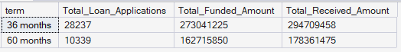
select
term,
count(id) as Total_Loan_Applications,
sum(loan_amount) as Total_Funded_Amount,
sum(total_payment) as Total_Received_Amount
from bank_loan_data
group by term
order by term

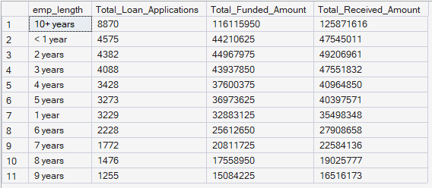

select emp_length,
count(id) as Total_Loan_Applications,
SUM(loan_amount) as Total_Funded_Amount,
SUM(total_payment) as Total_Received_Amount
from bank_loan_data
group by emp_length
order by count(id) DESC

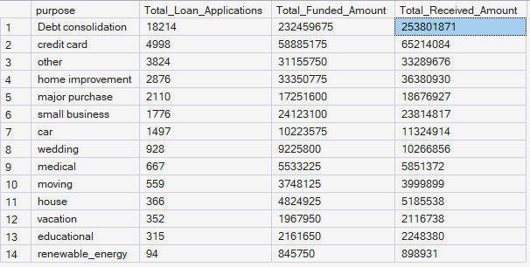

select purpose,
count(id) as Total_Loan_Applications,
SUM(loan_amount) as Total_Funded_Amount,
sum(total_payment) as Total_Received_Amount
from bank_loan_data
group by purpose
order by count(id) DESC

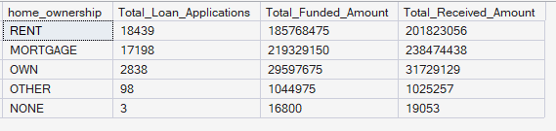

Select home_ownership,
count(id) as Total_Loan_Applications,
sum(loan_amount) as Total_Funded_Amount,
sum(total_payment) as Total_Received_Amount
from bank_loan_data
group by home_ownership
order by count(id) DESC

